# Node.js Download & Install:

Link: https://nodejs.org/en/download/

## NVM for Windows:

1. Download

<https://github.com/coreybutler/nvm-windows/releases> >>> [nvm-setup.exe](https://github.com/coreybutler/nvm-windows/releases/download/1.1.9/nvm-setup.exe)

1. Run >>> cmd >>> nvm

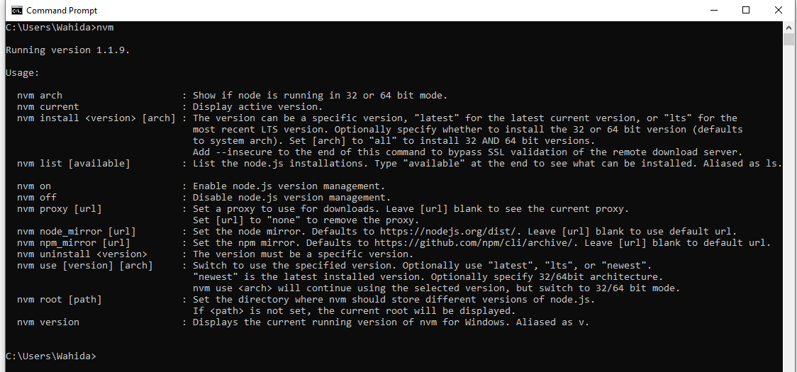

1. Run powershell or cmd

nvm ls



1. Run

nvm install latest

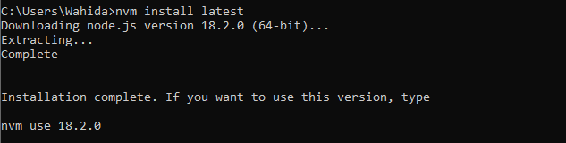

1. Check nvm version list to find the latest version of nvm

nvm list available

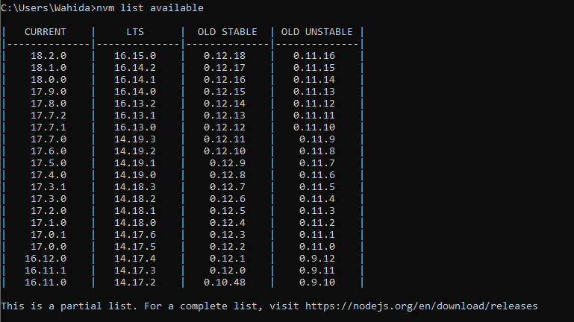

1. Run if latest version is not installed

nvm install 18.2.0

1. Run if want to replace existing version

nvm use 12.9.0

## First App Building Using Node.js:

1. Open your command line and create a new directory: mkdir HelloNode, then enter the directory: cd HelloNode
2. Create a JavaScript file named "app.js" with a variable named "msg" inside: echo var msg > app.js
3. Open the directory and your app.js file in VS Code using the command: code.
4. Add a simple string variable ("Hello World"), then send the contents of the string to your console by entering this in your "app.js" file:

JavaScript>>>>>>>>>>>>>>>>>>>>>>>>>>>>>>

var msg = 'Hello World';

console.log(msg);

1. To run your "app.js" file with Node.js. Open your terminal right inside VS Code by selecting **View** > **Terminal** (or select Ctrl+`, using the backtick character). If you need to change the default terminal, select the dropdown menu and choose **Select Default Shell**.
2. In the terminal, enter: node app.js. You should see the output: "Hello World".

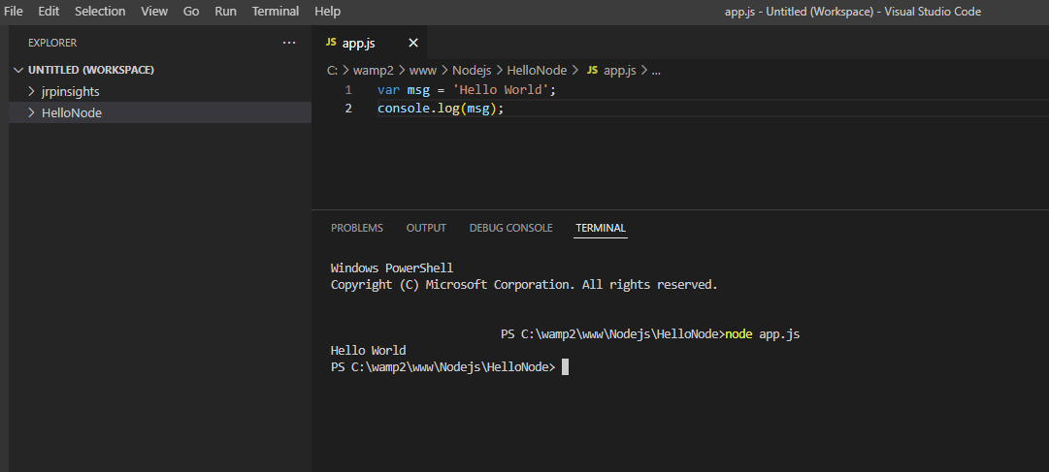

# Install Express.js

## Option 1:

1. Run >> cmd >> npm install -g express
2. To install latest version of express.js local to your project folder.

C:\MyNodeJSApp> npm install express --save

Option 2: Install Express.js in Visual Studio  
1. In the node.js web app, we created a simple node.js web application in Visual Studio. Now, to install Express.js, right click on the project MyNodejsWebApp -> select Install New npm Packages.

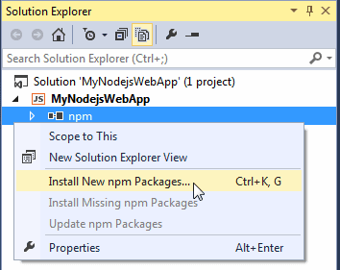

It will open the following dialog box.

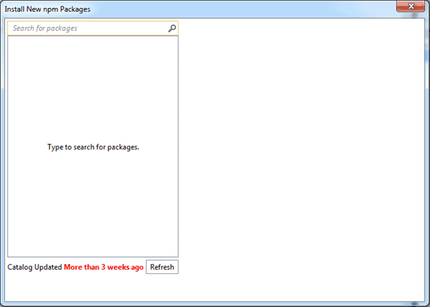

Now, type 'express' in the search box. It will display all the packages starting with express. Select latest version of express.js and select **Add to package.json** checkbox and then click **Install Package** button as shown below.

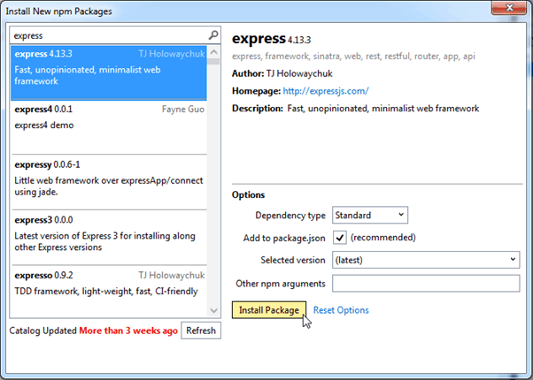

So, this will install express.js package into your project under node_modules folder. It also adds a dependencies entry for express.js as shown below.

